**LLM MODELS FOR SEMANTIC SENTIMENTAL ANALYSIS**

**INTRODUCTION**

Semantic Similarity Analysis in NLP measures the similarity between words, phrases, or sentences based on meaning. Common deep learning models used for this purpose include BERT, RoBERTa, ALBERT, XLNet, and T5. BERT, developed by Google, uses a bidirectional approach for understanding context and has been fine-tuned for tasks like Semantic Textual Similarity. RoBERTa, a variation of BERT by Facebook AI, improves performance on NLP tasks with additional training data. ALBERT, a compact version of BERT by Google Research, focuses on model size reduction while maintaining high performance. XLNet combines autoregressive and autoencoding models for bidirectional context capturing. T5, developed by Google, approaches NLP tasks in a unified text-to-text framework. These models can be fine-tuned on specific tasks for improved performance. Researchers often use pre-trained LLMs for Semantic Similarity tasks in applications like information retrieval and text summarization.

Here are some popular LLM Models used for Semantic Sentiment Analysis;

* BERT MODEL
* RoBERTa MODEL
* ALBERT(A lite BERT) MODEL
* XLNet MODEL
* T5(Text to Text Transfer Transformer) MODEL

1. **BERT MODEL:**

BERT, which stands for Bidirectional Encoder Representations from Transformers, is an advanced language model created by Google AI Language researchers. It uses a bidirectional approach to pre-train a deep neural network, allowing it to understand the context of words in a sentence effectively. BERT has revolutionized Natural Language Processing (NLP) and has raised the standards for language comprehension.

The model architecture of BERT involves transformer architecture, bidirectional training, and encoder mechanisms. It undergoes pre-training on large datasets using Masked Language Model (MLM) and Next Sentence Prediction (NSP) techniques for relational understanding. BERT's key innovations include a deep understanding of language context, remarkable accuracy in various NLP tasks, and overcoming limitations of previous language models.

BERT's impact and applications range from achieving state-of-the-art results in NLP tasks, such as Semantic Textual Similarity (STS) and Sentiment Analysis, to applications in Question Answering (QA) and Natural Language Inference (NLI). It has also been integrated into information retrieval systems and chatbots.

Different variants of BERT, like BERTbase and BERTlarge, have been explored, along with comparisons of model sizes and implications. Performance evaluation includes benchmarks, metrics, and success in various NLP benchmarks compared to other language models.

In conclusion, this detailed outline provides a comprehensive understanding of BERT's significance in NLP, covering its architecture, training, applications, variations, technical aspects, and societal impact. It also discusses future research directions and ethical considerations surrounding the model.

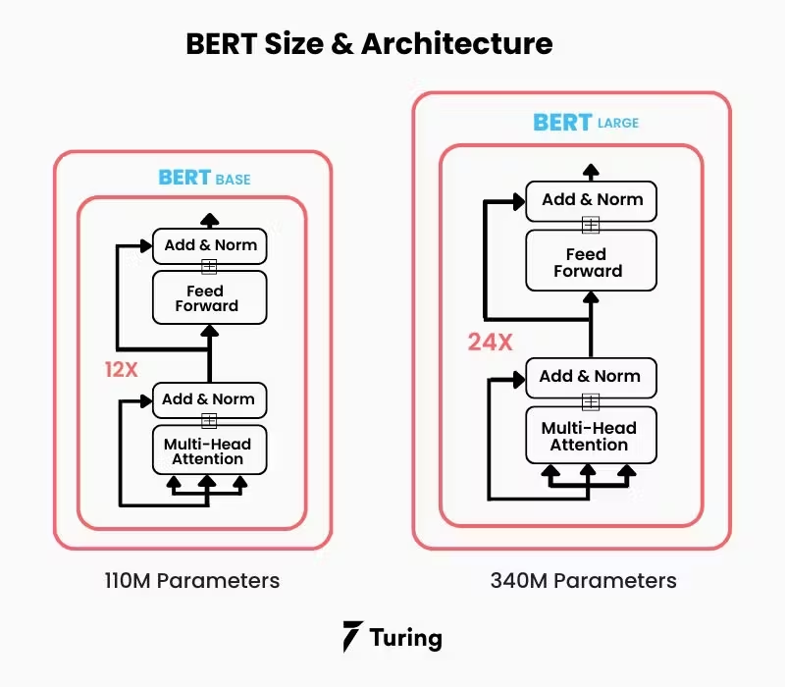

1. **RoBERTa MODEL:**

The content provides a detailed overview of RoBERTa, focusing on its architecture, key modifications from BERT, pre-training process, uses for text classification and named entity recognition, and a comparison with BERT.

RoBERTa is a significant model in Natural Language Processing (NLP) known for its architectural enhancements and improved performance compared to BERT. It is based on the BERT architecture but includes modifications such as the removal of the Next Sentence Prediction (NSP) objective and changes to the training process. RoBERTa excels in tasks like text classification, where its contextual embeddings are leveraged for accurate predictions. Additionally, it can be used for Named Entity Recognition (NER) by applying an output layer to predict tags for each token.

In comparing RoBERTa and BERT, RoBERTa outperforms BERT due to its larger pretraining corpus, training with larger batches, and other architectural improvements. The content also discusses the potential ethical and societal implications of RoBERTa, along with future research directions in the NLP field.Overall, the content provides a comprehensive guide for understanding RoBERTa and its implications in NLP, serving as a valuable resource for researchers and practitioners in the field.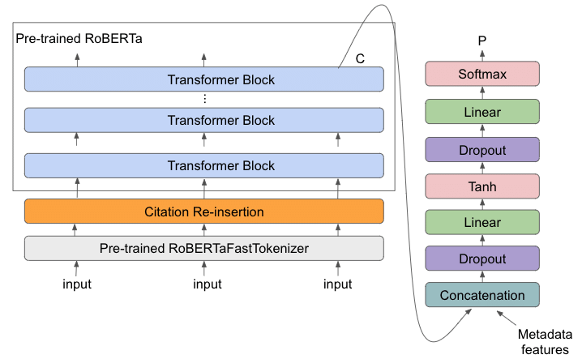

1. **ALBERT (A Lite BERT) MODEL:**

In 2024, AI models have made significant advancements, with systems like Google DeepMind's AlphaProof and AlphaGeometry 2 achieving impressive results in mathematical reasoning, demonstrating capabilities comparable to a silver medal at the International Mathematical Olympiad. Variations of the Albert model, such as Gemini Ultra and Gemini Pro, have also excelled, surpassing GPT-3.5 in benchmarks and showing promise as valuable research tools. Meta has also launched Llama 3.1 models with up to 405 billion parameters, highlighting the continued growth of AI.

The advancements in AI extend beyond mathematics, with the rise of multimodal AI leading to more versatile applications and virtual assistants that can interact seamlessly through various data inputs. There is a focus on developing domain-specific language models that yield greater outputs from smaller models, democratizing AI, enabling local use on smaller devices, and enhancing explainability. The emphasis is on maximizing the performance of compact models and making optimization more accessible.

While AI systems have made significant progress, challenges such as long processing times and the need for faster speeds than the human brain remain. Despite these limitations, AI is regarded as a valuable research tool, providing answers to various questions and offering utility in various industries.

Overall, 2024 is a crucial year for AI development, with advancements in mathematical problem-solving, multimodal AI, and domain-specific language models solidifying AI's role as an essential tool for industry applications and research.

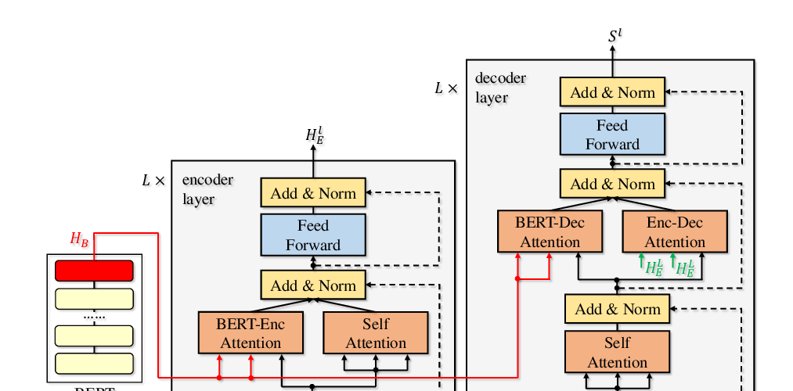

1. **XLNet MODEL:**

XLNet, an advanced NLP model developed by Google AI Language, surpasses previous models like BERT through its permutation language modeling approach. By considering all possible permutations of input sequences during training, XLNet captures bidirectional context effectively, leading to improved accuracy and performance on NLP tasks. Its state-of-the-art performance on tasks such as text classification, question answering, and language modeling showcases its ability to understand language semantics and syntax deeply. Based on the Transformer model, XLNet integrates self-attention mechanisms and training techniques to achieve superior performance efficiently. This innovative approach signifies a significant progress in NLP, demonstrating the potential of transformer-based models in enhancing text understanding, generation, and translation.

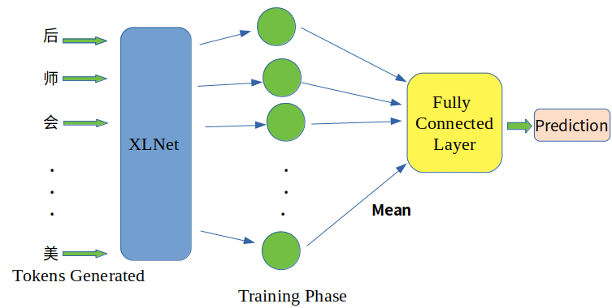

1. **T5(Text to Text Transfer Transformer) MODEL:**

The T5 (Text-to-Text Transfer Transformer) model, developed by Google researchers, is a powerful and versatile natural language processing (NLP) model that approaches all tasks as text-to-text problems. It is based on the Transformer architecture, known for its ability to capture long-range dependencies in sequences effectively. T5 can handle tasks like translation, summarization, question answering, and text classification by adjusting input and output formats while keeping the model architecture constant.

T5 has shown state-of-the-art performance on different benchmarks and competitions, proving its effectiveness in handling diverse NLP tasks and datasets. Its ability to generalize across tasks and domains while maintaining strong performance has made it popular among researchers and practitioners in the NLP community.Its versatility, performance, and ease of fine-tuning make it a valuable tool for NLP research and practical applications in language understanding, generation, and information retrieval.

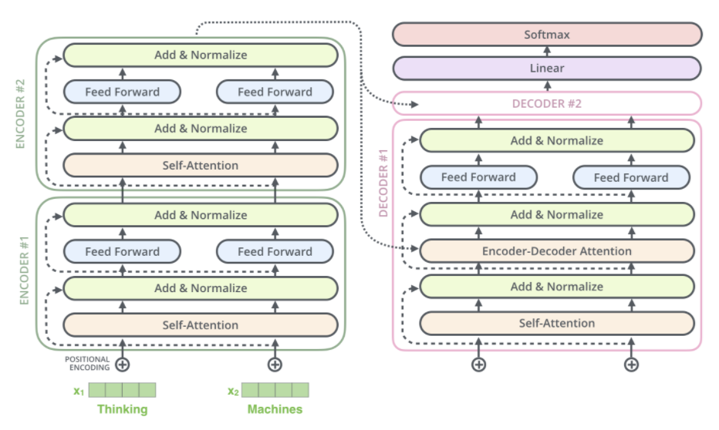

REFERENCES:

1.<https://whylabs.ai/learning-center/llm-use-cases/sentiment-analysis-with-large-language-models-llms>

2.<https://www.technologyreview.com/2024/01/04/1086046/whats-next-for-ai-in-2024/>

3.<https://www.technologyreview.com/2024/07/25/1095315/google-deepminds-ai-systems-can-now-solve-complex-math-problems/>